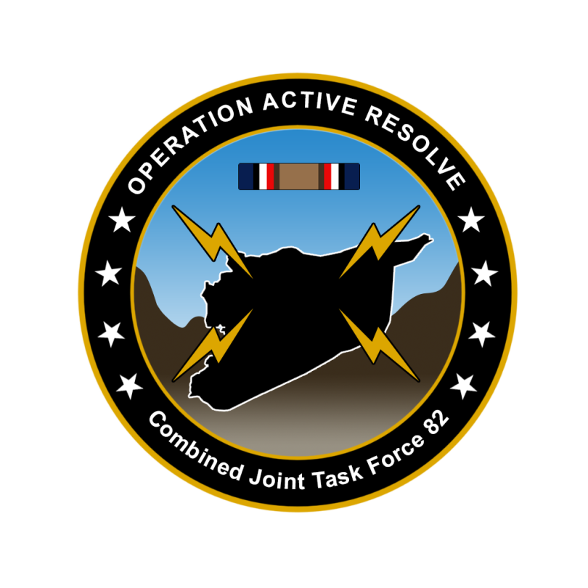

CJTF-82 DIRECTION AND GUIDANCE

D+12

This document covers the friendly situation from D+11 and provides CJTF-82 guidance to the entire force.

**Reference CombatFlite**: <https://132nd-vwing.github.io/OPAR-Brief/MISSION%20INFORMATION/Friendly_update.cf>

# SITUATION

## General situation

September 1st 2011 JFACC initiated airstrikes against Syrian forces while LCC started preparing its offensive. On D+3 LCC with its IV Corps in Sector North started its offensive.

There has been a higher Russian activity in the eastern Mediterranean than normal and this is likely due the presence and operations from CJTF-82.

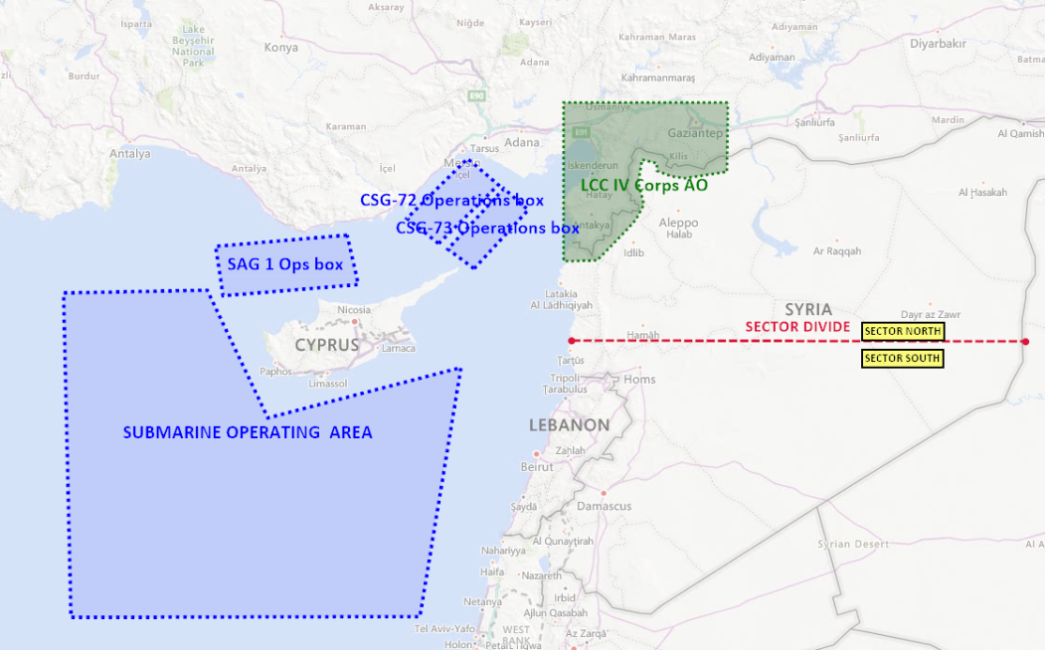

## Friendly situation

### Land Component Command (LCC)

#### IV Corps (Northern sector)

55th Division is static at the FLOT to prepare for assault into Syria in PHASE 2

56th Division is static at the FLOT to prepare for assault into Syria in PHASE 2.

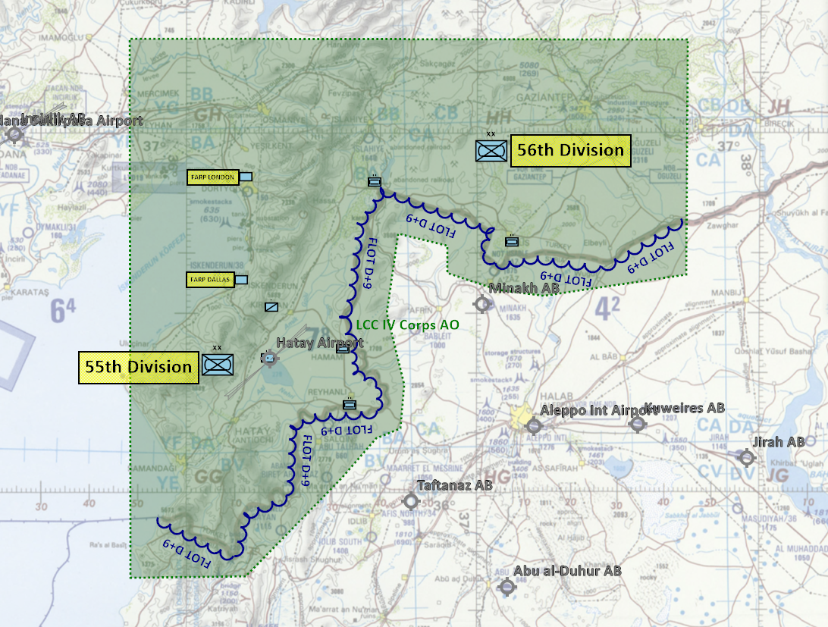

#### III Corps (southern sector)

III Corps was planned to starts its offensive at D+4. However, due to low attrition of the Syrian 3rd Corps the offensive is delayed. III Corps will start its offensive when conditions are set for starting the offensive. Conditions set for offensive start is 35% attrition on the following enemy units:

* 30th Armored Division (Syrian 3rd Corps)
* 31st Mechaniced Division (Syrian 3rd Corps)
* 32nd Motorized Division (Syrian 3rd Corps)

### Maritime Component Command (MCC)

* CSG-72 continues to support the mission from CSG-72 operations box. The operations box has been moved closer to Incirlik to be able to generate more sorties.
* CSG-73 have been added to CJTF-82 to increase the availability of sorties, and provide flexibility for operations by having carriers available at various locations.
* SAG-1 continues to support the mission by creating a screen for potential Russian interference from the WEST.
* CJTF MCC is commanding the submarine SSN-688 USS Los Angeles. The mission for the submarine is to deny Russia freedom of action in the eastern Mediterranean

### Joint Force Air Component Command (JFACC)

* IAW JFACC JAOP and AOD’s

### Special Operations Component Command (SOCC)

* Several SOF teams have started insertion into Syria to prepare for CJTF-82 Operations order phase 2.
* SOF teams are also on standby to conduct counter terrorism missions and counter insurgency operations.

# Reported Battle Damage Assessment D+11

## IV Corps (Northern Sector)

* NSTR

## III Corps (Southern Sector)

* NSTR

# Direction and Guidance

## LCC:

* Priority of effort is on the NORTHERN sector and support of IV Corps in preparing for ground assault into SYRIA in phase 2.
* Prepare plan for phase 2
  + Submit CONOP (Concept of Operations) to CJTF HQ for approval
  + CONOP submitted NLT D+12.

## MCC:

* Screen friendly operations from Russian units.
* BPT move CSG-72 operations box based on JFACC needs.

## JFACC:

* Priority of effort is on establishing Air Superiority in support of LCC in the northern sector.
* Start shaping for phase 2 in the operation
  + For support to LCC, support shaping effort for LCC by removing enemy long range artillery, attack helicopters, C2, logistics and artillery.
* Prepare plan for phase 2.
  + Revise priority on Joint Target List (JTL).
  + Plan need to take into account support to LCC (CAS, AR and CAP) and Air Interdiction campaign for targets at JTL.
  + Submit CONOP (Concept of Operations) for phase 2 to CJTF HQ for approval.
    - CONOP can contain options to fly through neutral territory.
    - CONOP can contain options for attacking adversary’s posing a threat to the phase.
    - CONOP can contain request for MCC to move CSG-72 operations box
    - CONOP can contain request to SOCC for observation posts for target acquisition in enemy territory
* Prepare contingency plans for striking Syrian WMD at short notice (regardless of phase).
  + ALR: EXTREME approved for such a plan.
  + This needs to be a executable plan, with all necessary C2 arrangement, targets, deconfliction, support in place.

## VIS:

* Make a recommendation for start of phase 2, on the following conditions:
  + Favorable air superiority in northern sector
  + Syrian long range artillery (MLRS) in northern sector reduced with 75%
  + Syrian artillery in northern sector reduced with 50%
  + Syrian attack helicopters reduced with 50%
* Support JFACC with recommendations for phase 2

Definition of northern sector units: 1st Corps and 2nd Corps.

## Diplomatic situation

* Syria is declared as enemy
* Russia is declared as adversary
* Jordan is declared as neutral
* Lebanon is declared as neutral
* Turkey is declared as friendly
* Israel is declared as friendly
* China is declared as adversary

Only units declared as enemy can and should be engaged by CJTF forces.

**Definitions:**

Enemy: is actively opposed or hostile to CJTF and friendly forces.

Adversary: opponent in a contest, conflict, or dispute toward CJTF and friendly forces.

Neutral: not supporting or helping either side in a conflict, disagreement, etc.; impartial.